

Department of Electrical & Computer Engineering
Operating Systems
ECCE 354

Developing Your Own Shell:
Assignment Report

Eiman Alwahhabi 100044615
Feruz Kiflay Elmay 100043381
Afnan Ali Alhosani 100042677

Submitted to: Dr. Youssef Iraqi
Submission Date: April 30th, 2019
Spring 2019

Table of Contents
Table of Contents 2
Introduction 3
Functionalities and Design 4
Prompt 4 4
Reading Command Line 4
Parsing 4
Built-in Command 5
A. Change Directory 5
B. Exit 6
C. Jobs 6
D. Kill 7
E. History 7
Non-Built-in Commands 7
Redirecting 8
Conclusion 9
Appendix - Code 9

Introduction

A shell is a user-interface that provides access operating systems’ services such as executing programs. This is done by feeding the shell with commands in particular syntax to receive an output in a form of a message, list or a table. The shell goes through continuous cycles of prompt-read-execute, where it first displays a message to the user, reads the command line and executes it.
This assignment requires students to building their own command shell to gain experience with development techniques for process creation and management, file management, signals and pipes. Moreover, it requires students to apply knowledge acquired in class to implement an executable program that mimics an actual command shell.
For this assignment, students were asked implement 9 essential functions in the shell. Students were able to establish all essential functionalities with minor fallbacks while no bonus features were not attempted. Moreover, they were able to identify the role of the operating system in executing privileged commands and using that to build the shell.
The programming language used is C language since it’s suitable in terms of communicating with the hardware and granting the operating system full control and access. The working environment best suitable to run the shell program is Linux min cinnamon 64 but shows compilation errors while running on MacOS. The developing model used is the incremental software development model where each independent function was developed and tested individually before it has been integrated in the program in a cycle similar to the one shown in Figure 1.
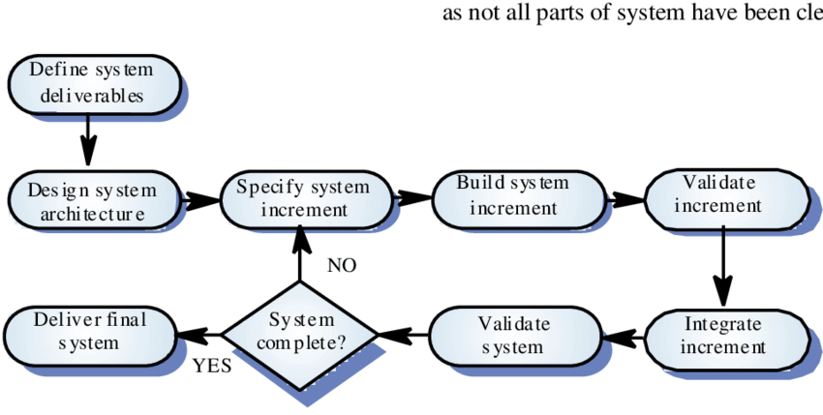

Figure 1 Incremental Software Development Model Cycle used in Developing the Shell

Functionalities and Design

Prompt

The void function printPrompt() is constructed and called in the main function. It uses the function path.conf() to attain the maximum size of the file’s path. “Ptr” is the name of the pointer that will be used to hold the path name of the working directory. We dynamically allocate memory to the buffer using malloc() of size character before using getcwd() function to print the current working directly as seen in Figure 2. We lastly use free() function to de-allocate memory to the buffer to help reduce wastage of memory until next time prompt function is called.
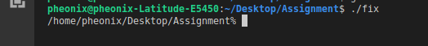

Figure 2 Prompt Function Result

Reading Command Line

readCommandLine() is a void function that and uses fgets(intput,size,stdin) to read user’s line of input. “Input” is a pointer to an array of characters where the read string is copied. “stdin” is a pointer to file object that can be used as argument to read from standard input. The length of the string is extracted to replace the last new line’s character that fgets() returns along with input read. A case is handled in the main function where if the command line had a length of zero it means nothing was enter by the user thus the prompt function executes again. It also handles the case where the user uses “&” to run commands in the background.

A function index_Check is also used in the scoop of readCommandLine(). This function checks the first index of the command to display of nth command saved in the FIFO array of history or repeat the last entered command. History is implemented using a structure called historyStruct that contains a pointer array for commands of size 1KB and a counter. In index_Check, if the history’s counter was zero it will display an error function to the user. If history counter has a positive value other than 0, then copies the string into another string to be displayed.

Parsing

parsing functionality is found in readCommadLine’s body to save time while running the shell instead of jumping. This is because the command line input would’ve been used as a parameter for the parsing function if it was a stand alone function. strtok() is used to split the string into tokens according to a delimiter which is whitespace. The function is called in a loop where it returns NULL when there are no more tokens. In the loop, memory is allocated to each element of the array “tokens” which is an array of pointers and used to hold each token extracted. Also, a counter is updated with each irritation of the loop and assigned to the global variable “noOfArgs” to be used in other function such as index_Check.

Built-in Command

Built-in commands are commands that can execute in the shell itself instead of an external program. They’re also command that are executed by the parent process such that fork() system call is not needed. There are 5 commands that are built-in and required for this assignment. isBuiltInCommand is an integer type function that would return a flag if the first pointer in argv (the command) was identical to either (cd, jobs, kill, exit or history). If isBuiltInCommand was evaluated as true, the command entered by the user (tokens[0]) is compares to one of the built in command to execute the proper functionality.

Change Directory

cd_function is a void type function that evaluates tokens [1]’s syntax, which the new path that the user wants to switch to. Using getenv() function, it searches for the environment string pointed to by “HOME” and returns the associated value to the string. Chdir function is executed after evaluating if the path exits or not. The following figures show the results of cd command:

Figure 3 Implementing (cd) - Changing to Home Directory

Figure 4 Implementing (cd Documents) - change of directory

Figure 5 Implementing (cd ..) - Moving upward in the File system

Figure 6 Implementing cd with a Root Directory

Exit

To support a graceful exit, before implementing the exit(0) the user is informed of the background jobs that are currently running. Also, the user is informed that to exit the shell with running background job, it’s better to before a kill system call. Look at figure 7 for implementation results.

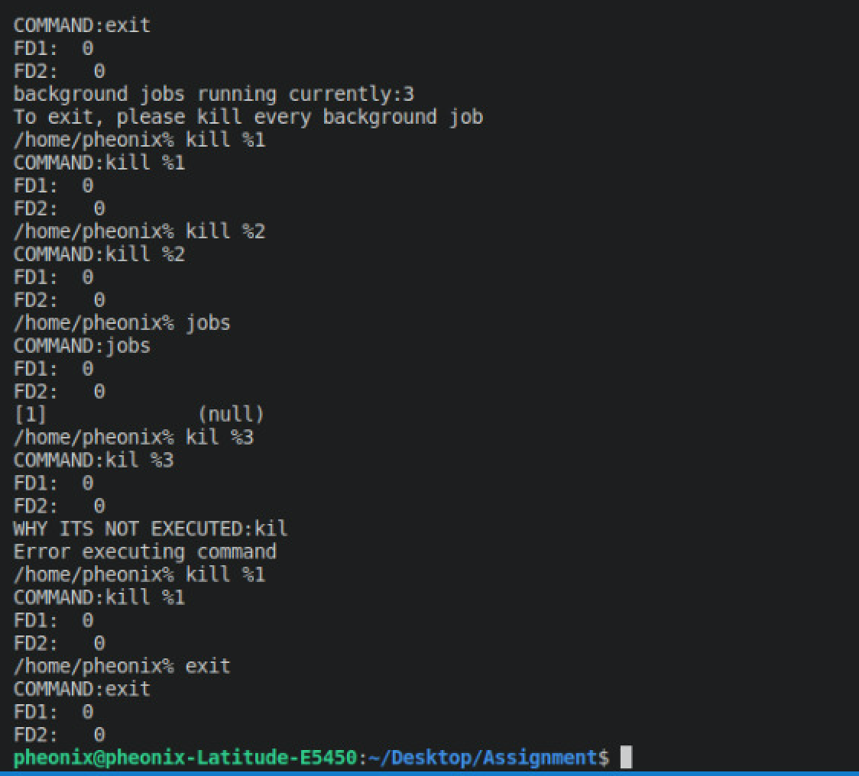

Figure 7 Implementing a Graceful Exit

Jobs

Jobs_func is a void type function that takes the structure backGdCommands as a parameter to access the counter and the array of the structure. If background jobs’ counter is zero, an error message is displayed informing the user that no background jobs exist else a for loop is used to display the content of array containing the background jobs. See figure 8 for how jobs is executed.
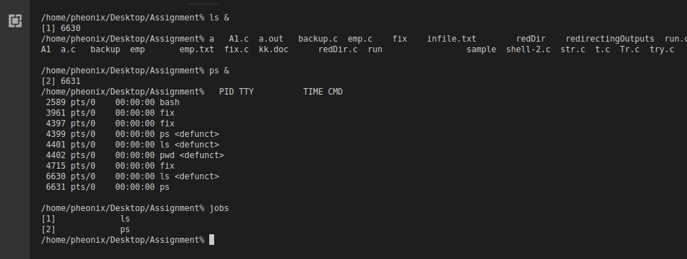

Figure 8 Implementing Jobs

Kill

Kill_function is a void type function that takes the structure background job as parameter. By using the function kill(), a signal is sent to the process of certain ID that is then removed from the list of background processes returned by job using remove_bGJob. The processor’s number is removed by shifting the elements in the array and decrementing the number of background jobs. Look at Figure 9 for Kill results.
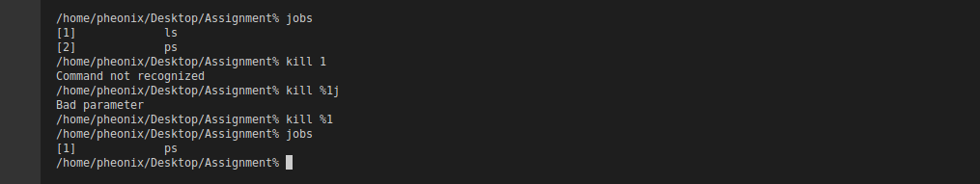
Figure 9 Implementing Kill Command

History

History is a void function that takes the structure historyStruct as a parameter to access the counter in the structure. The counter is a valuable for displaying the content of the structure’s array that holds up to 5 commands. If the counter was zero, an error message is displayed to the user. If the counter has more than 5 items, memory moments is done to display the top five only. Using a for loop to list content of the history array from Last entered to First in. Look at figure 10 for history implementation results.
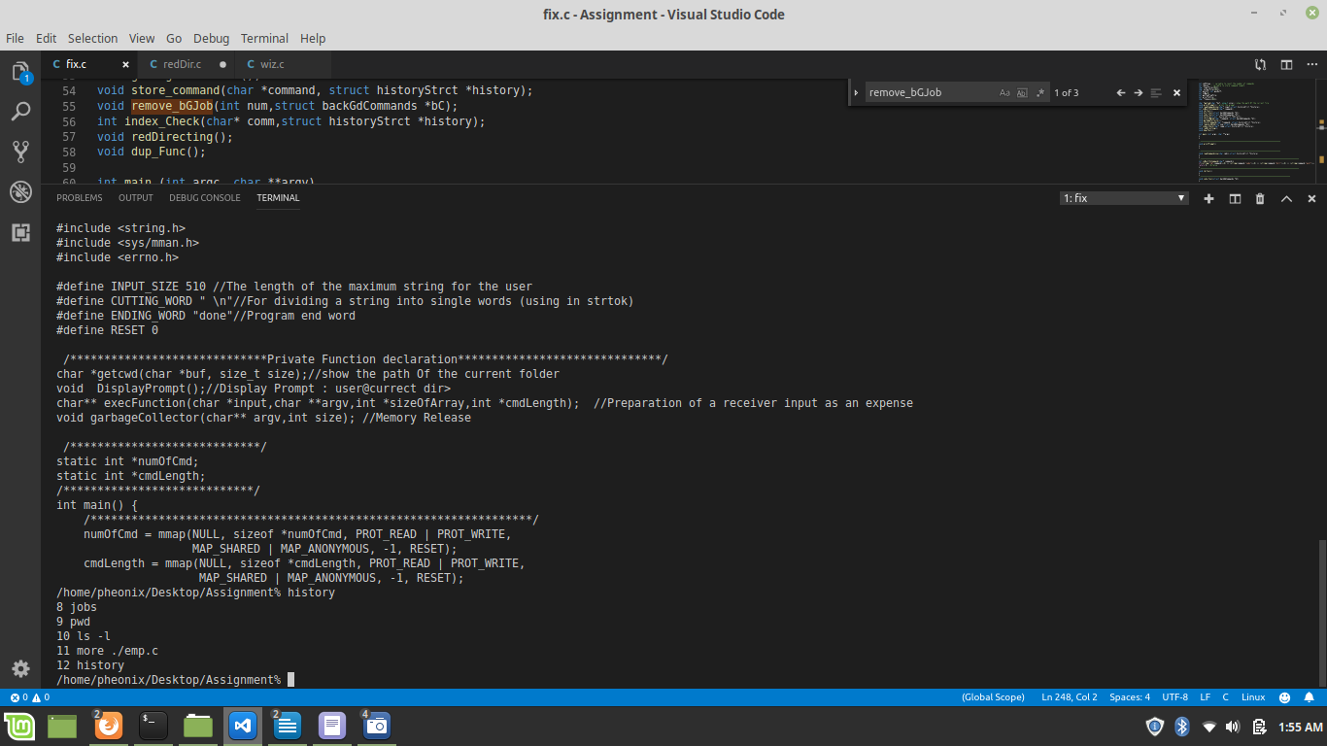
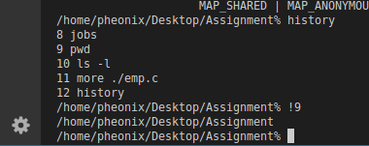
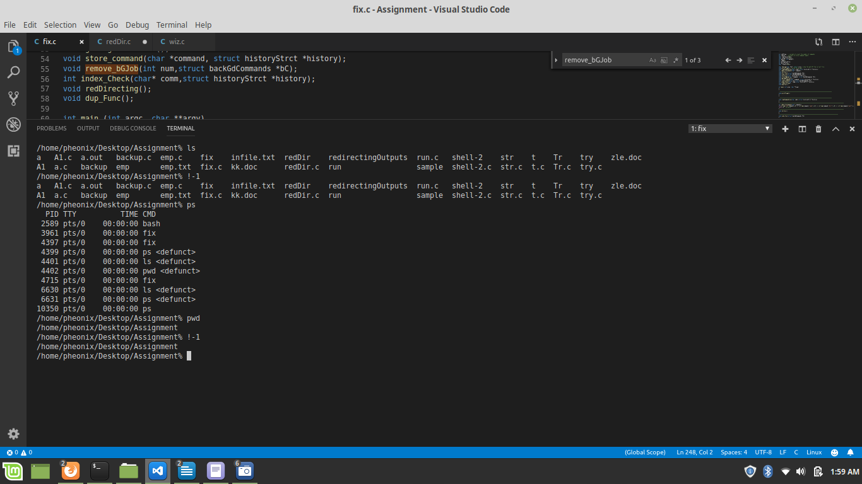
Figure 10 Implementing History Command and More

Non-Built-in Commands

This part of the shell is to execute commands that may need external program to run. This is done by using a fork system call that will create a child process from a parent process. Fork will return the ID of the child to the parent and zero to the to the child. If the child receives zero, it executes the command using execvp system call. If not, the parent has to wait for the child to exit.
All commands beside the built-in commands are non-built in and are executed in this code segment. One of the features that is handled in this segment is allowing the user to specify commands by absolute or relative pathname. This is done by using the “which” command that helps in identifying the location of executables. It simply tells which PATH directory contains a command.
Another feature that the shell supports environment variables especially PATH which is a list of directories in which to look for specified executable. By typing “$PATH” in the shell, a horizonal list of directories separated by colons as seen in Figure 11.

The shell can execute “ls” command which lists the content of the current directory. Moreover, the shell can also execute “ls -1” which will give a detailed list of files in current directory along with their 9 bits security codes. It also supports executables such as mkdir, rmdir and also absolute and relative paths.
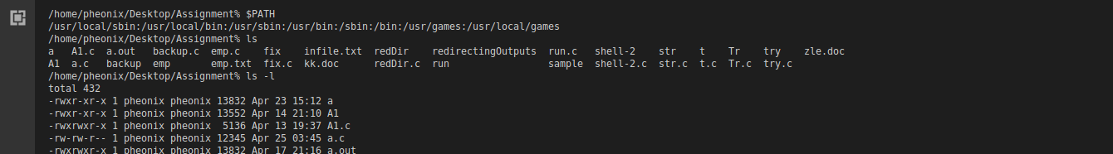
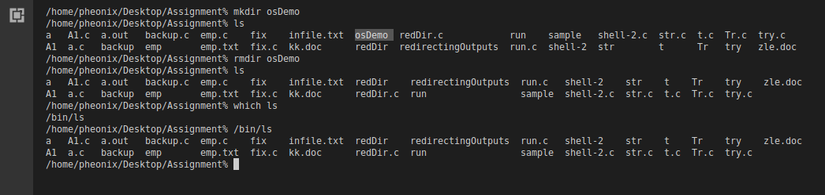
Figure 11 Implementing PATH command
Figure 12 Implementing ls command is different directories

Redirecting

The shell supports redirecting STDIN and STDOUT using < and >. This is done by using dup2 system call that duplicates one file descriptor and then deleting the old file descriptor. File descriptor should be a small non-negative integer. If file descriptor equals zero, this means it will use STDIN redirect input from the file. If file descriptor equals 1, this means it will use STDOUT to redirect the input from the shell to file.

In case of the builtin commands, this redirecting method checks for the redirecting sign and sets them to 1 if they exist in the command given. Then this function calls another method called the dub_Func() which does the file descriptor duplicating and replacing. However in case of the non-builtin commands, the there is one more step added that is the use of dub. Since the STDIN_FILENO and the STDOUT_FILENO have to be saved for later use, the dub() system call copies these numbers to an integer variable before their values are replaced by those of the files we want to direct the output or gt input from. Moreover, when dup2() is called and the process of inputting and outputing is done, the STDIN_FILENO and the STDOUT_FILENO values are copied back and the program resumes.
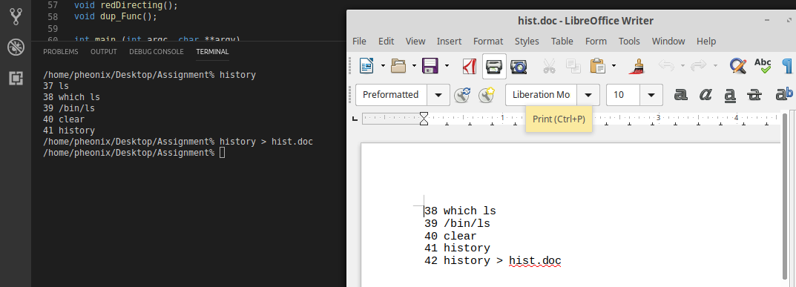

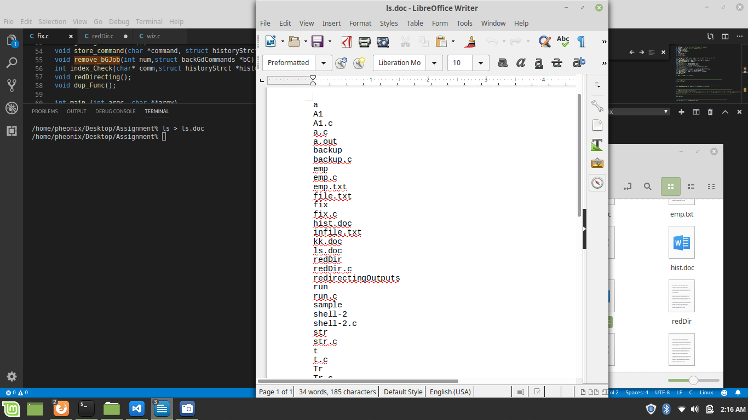

Figure 11 Implementing Redirecting to a File

Conclusion

In conclusion, students have achieved the objectives of this assignment by implementing a fully functional shell. They’ve also learnt about systems calls and the role of the operating system in executing commands. Moreover, students learnt how to search functionalities of a system call by using man command provided by the shell. Implementing the shell was challenging but it enhanced the understanding of what has been taught in class and sparked interest in students to learn more about the command line shell.

